4.21 Using Fig. 4.89, design a problem to help other students to better understand source transformation.

Although there are many ways to work this problem, this is an example based on the same kind of problem asked in the third edition.

Problem

Apply source transformation to determine v_{o} and i_{o} in the circuit in Fig. 4.89.

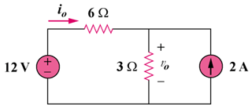

Figure 4.89

Solution

To get i_{o}, transform the current sources as shown in Fig. (a).
6 Ω
12V

+
−
3 Ω
i_{o}
6V

+
−
(a)
2 A
6 Ω
i
3 Ω
(b)
2 A
+
v_{o}
−

From Fig. (a), -12 + 9i_{o} + 6 = 0, therefore i_{o} = 666.7 mA

To get v_{o}, transform the voltage sources as shown in Fig. (b).

i = [6/(3 + 6)](2 + 2) = 8/3

v_{o} = 3i = 8 V

